**Practical 09 Configure Voice Over IP(VOIP) in Packet Tracer.**

Step 1: Take one router and two IP phone and one switch and set proper connections among them.

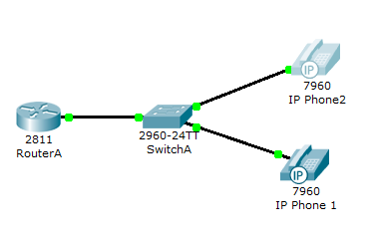

Step 2 :  when we try to go to any other mode its give us error and ask us to switch it on first. For that, go to Physical mode and put the power adapter (in the bottom right corner) into the phone as shown in figure.

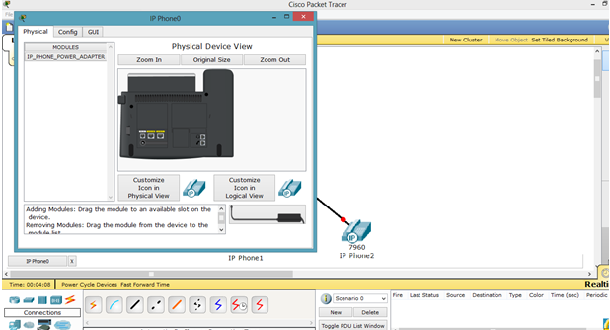

Step 3 : Now, go to router and assign IP address.

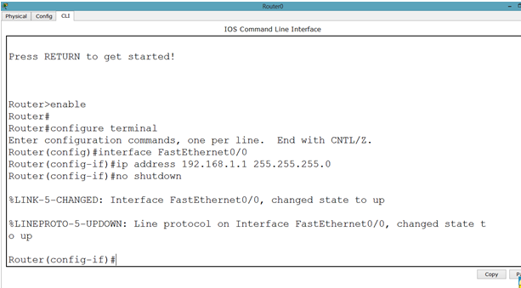

Step 4 : We will have to set DHCP server on router to assign IP addresses to IP phones.

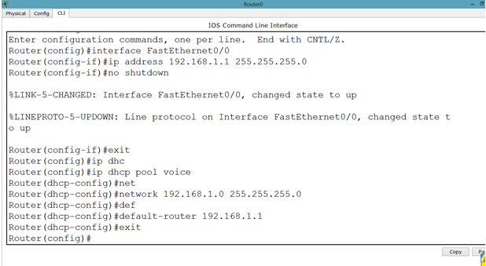

Step 5 : let us apply commands to the router for voip. You might have noticed we took 2811 series router because it facilitates the following commands.

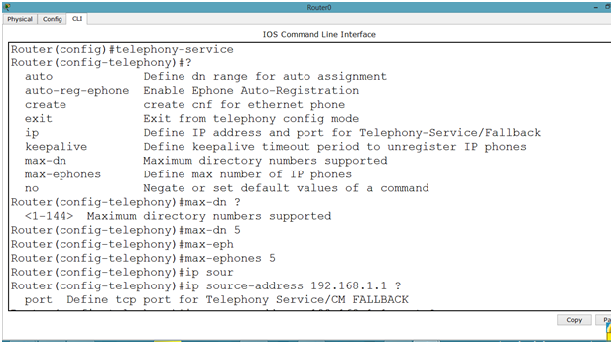

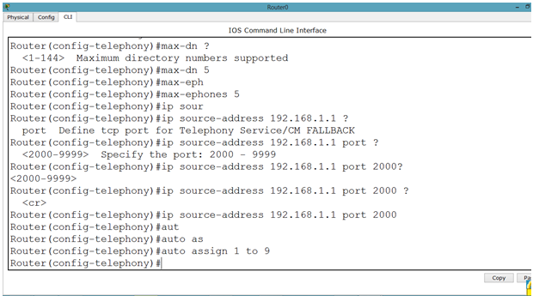

Step 6 : Now, we will go to the switch and make the interfaces support voip as follows.

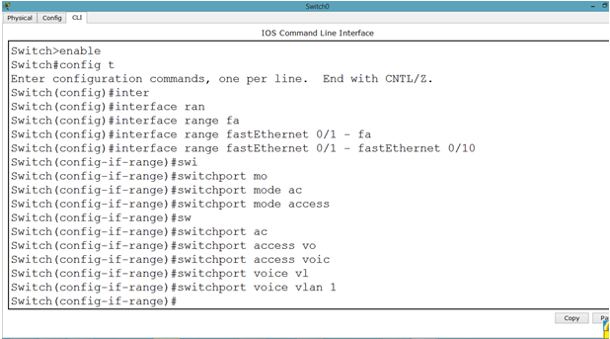

Step 7 : After that, we will have to assign phone number to our IP phone by applying following commands.

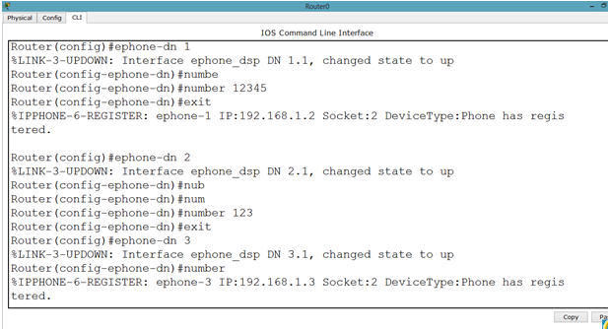

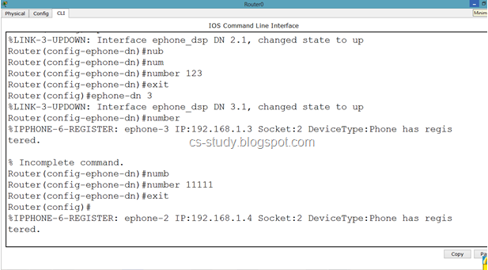

Step 8 : Now, we can see that in GUI mode of Phone, we have a phone number available. This means that we can call from one phone to the other. Lets do that.

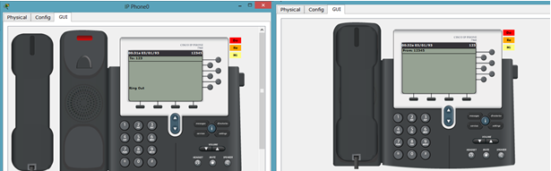

And when we pick up the reciever, it says that we are connected.

